RSA model comparison
S1=a capella, S2=instrumental, S3=spoken, S4=whole
Files | mask | Model | stats
scan2_Run1_fam  scan2_Run2_fam  Two halves of second session familiar data | Mask.nii  (whole brain) | 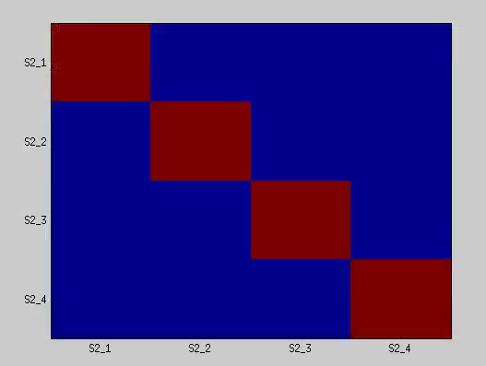 | Each individual’s correlation matrix was correlated with the model.  The average correlation = -0.0197  ttest of individual correlation values:  t=-0.36, p=0.7193
scan2_Run1_fam  scan2_Run2_fam  Two halves of second session familiar data | CombinedAvgEffect.nii  (based on univariate activation) |  | Each individual’s correlation matrix was correlated with the model.  The average correlation = 0.0184  ttest of individual correlation values:  t=-0.44, p=0.6620
scan2_Run1_fam  scan2_Run2_fam | Mask.nii  (whole brain) | Lyric model  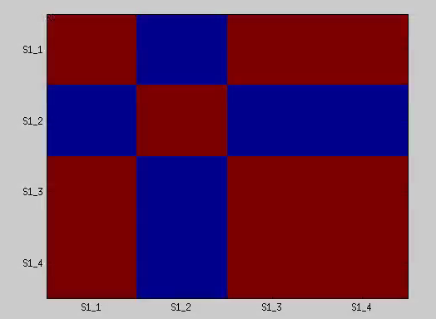 | Each individual’s correlation matrix was correlated with the model.  The average correlation = -0.0045  ttest of individual correlation values:  t=-0.0718, p-0.9435
scan2_Run1_fam  scan2_Run2_fam | CombinedAvgEffect.nii  (based on univariate activation) | Lyric Model | Each individual’s correlation matrix was correlated with the model.  The average correlation = 0.0145  ttest of individual correlation values:  t=0.2430, p=0.8108
scan2_Run1_fam  scan2_Run2_fam | Mask.nii  (whole brain) | Music model  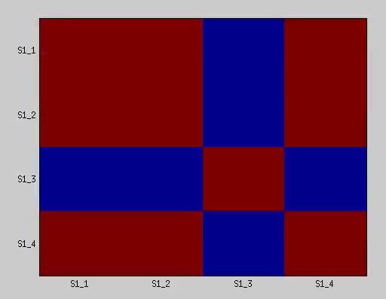 | Each individual’s correlation matrix was correlated with the model.  The average correlation = -0.0335  ttest of individual correlation values:  t=-0.589, p=0.5632
scan2_Run1_fam  scan2_Run2_fam | CombinedAvgEffect.nii  (based on univariate activation) | Music model | Each individual’s correlation matrix was correlated with the model.  The average correlation = 0.0303  ttest of individual correlation values:  t=0.4034,p=0.6914
The data from the four familiar songs in the second session do not follow the pattern of the model where the same stimulus in one half of the data is correlated with the second half.
Correlations are also not signficantly different from 0 based on the lyric or music models.
scan12_Run1_fam  scan12_Run2_fam  combined data for both scans, but split across Runs | Mask.nii | 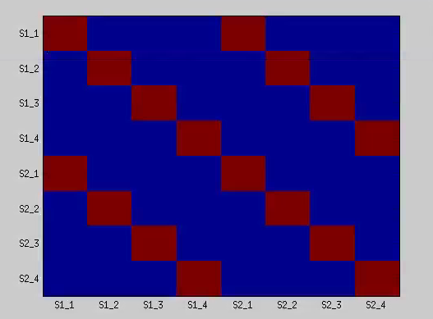 | Each individual’s correlation matrix was correlated with the model.  The average correlation = -0.0063  ttest of individual correlation values:  t=-0.3444,p=0.7345
scan12_Run1_fam  scan12_Run2_fam  combined data for both scans, but split across Runs | CombinedAvgEffect.nii |  | Each individual’s correlation matrix was correlated with the model.  The average correlation = 0.0817  ttest of individual correlation values:  t=4.2187, p<0.001
scan12_Run1_fam  scan12_Run2_fam  combined data for both scans, but split across Runs | Mask.nii | Lyric model  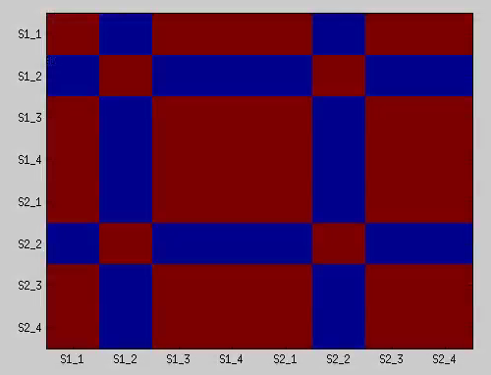 | Each individual’s correlation matrix was correlated with the model.  The average correlation = -0.0137  ttest of individual correlation values:  t=-0.4730,p=0.6419
scan12_Run1_fam  scan12_Run2_fam  combined data for both scans, but split across Runs | CombinedAvgEffect.nii | Lyric model | Each individual’s correlation matrix was correlated with the model.  The average correlation = 0.0192  ttest of individual correlation values:  t=0.6652, p=0.5144
scan12_Run1_fam  scan12_Run2_fam  combined data for both scans, but split across Runs | Mask.nii | Music model  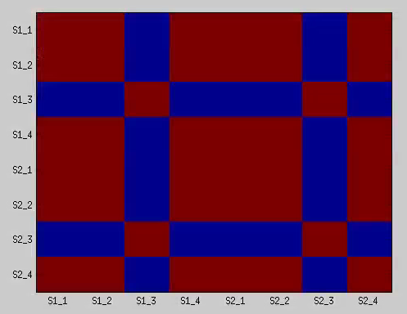 | Each individual’s correlation matrix was correlated with the model.  The average correlation = -0.0147  ttest of individual correlation values:  t=-0.4933, p=0.6278
scan12_Run1_fam  scan12_Run2_fam  combined data for both scans, but split across Runs | CombinedAvgEffect.nii | Music model | Each individual’s correlation matrix was correlated with the model.  The average correlation = 0.1639  ttest of individual correlation values:  t=4.5745, p<0.001
When comparing familiar stimuli within the two scans, a ttest of the correlations of individuals with the model shows significant correlations against 0. Average is very small. (scan1 and scan2 on both the X and Y axes)
Only seen in the areas defined in the univariate analysis
There is also a significant correlation of individual correlation matrices in the music model but only in the areas defined by the univariate analysis.
scan1_12_fam  scan2_12_fam | Mask.nii | 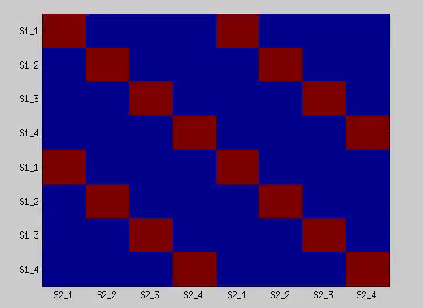 | Each individual’s correlation matrix was correlated with the model.  The average correlation = 0.0138  ttest of individual correlation values:  t=0.7037, p=0.4906
scan1_12_fam  scan2_12_fam | CombinedAvgEffect.nii |  | Each individual’s correlation matrix was correlated with the model.  The average correlation = 0.0957  ttest of individual correlation values:  t=4.8696,p<0.001
scan1_12_fam  scan2_12_fam | Mask.nii | Lyric Model  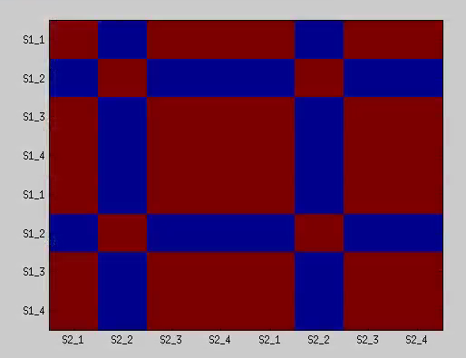 | Each individual’s correlation matrix was correlated with the model.  The average correlation = 0.0116  ttest of individual correlation values:  t=0.4769,p=0.6392
scan1_12_fam  scan2_12_fam | CombinedAvgEffect.nii | Lyric Model | Each individual’s correlation matrix was correlated with the model.  The average correlation = 0.0283  ttest of individual correlation values:  t=1.0270,p=0.3180
scan1_12_fam  scan2_12_fam | Mask.nii | Music model  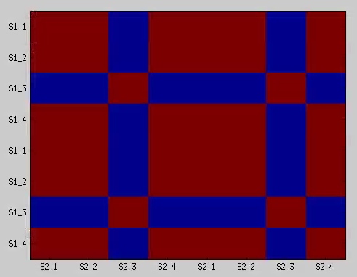 | Each individual’s correlation matrix was correlated with the model.  The average correlation = 0.0323  ttest of individual correlation values:  t=1.5175,p=0.1465
scan1_12_fam  scan2_12_fam | CombinedAvgEffect.nii | Music model | Each individual’s correlation matrix was correlated with the model.  The average correlation = 0.2038  ttest of individual correlation values:  t=5.8423,p<0.001
When comparing familiar stimuli across the two scans, a ttest of the correlations of individuals with the model shows significant correlations above 0. Average is very small. (scan1 on X axis, scan2 on Y axis)
Only seen in the areas defined in the univariate analysis
There is also a significant correlation of individual correlation matrices in the music model but only in the areas defined by the univariate analysis. Correlation higher than significant correlation by ‘type’ (0.2 vs 0.09)

scan1_2_A  scan1_2_B | Whole brain mask | Stimulus model | Mean = 0.0781  t=5.2081, p <0.01
scan1_2_A  scan1_2_B | CombinedAvgEffect | Stimulus model | Mean=0.1713  t=10.2510, p<0.001
scan1_2_A  scan1_2_B | Whole brain mask | Type | Mean = 0.1093  t=6.8489, p<0.001
scan1_2_A  scan1_2_B | CombinedAvgEffect | Type | Mean = 0.2509  t=10.31 p<0.001
scan1_2_A  scan1_2_B | Whole brain mask | Lyric | Mean=0.1247  t=4.9114,p<0.001
scan1_2_A  scan1_2_B | CombinedAvgEffect | Lyric | Mean=0.1963  t=6.8722,p<0.01
scan1_2_A  scan1_2_B | Whole brain mask | Music | Mean=0.1262  t=5.37, p<0.001
scan1_2_A  scan1_2_B | CombinedAvgEffect | music | Mean=0.3838  t=10.25,p<0.001

Ttest
whole_music vs whole_lyric – NOT SIG
Whole Music vs whole_type – NOT SIG
whole_lyric vs whole_type – NOT SIG

avgeffect_music,avgeffect_lyric – t=4.7871, p<0.001
avgeffect_music,avgeffect_type – t=5/6216, p<0.001
avgeffect_type,avgeffect_lyric NOT SIG

